**(a)**

(i) A ∪ B = {1, 3, 4, 5, 7} and A ∩ B = {1, 7}

(ii) A \ B = {4, 5} and B \ A = {3}

(iii) A △ B = {3, 4, 5}

(iv) A x Ø = Ø and A x (B \ A) = {<1, 3>, <4, 3>, <5, 3>, <7, 3>}

**(b)**

(i)  
Reflexive: ∀ x ∈ A (<x, x> ∈ R)

Symmetric: ∀ <x, y> ∈ A^2 (<x,y> ∈ R ⇒ <y, x> ∈ R)

Transitive: ∀ <x, z> ∈ A^2 (∃y ∈ A (<x,y> ∈ R ∧ <y, z> ∈ R) ⇒ <x, z> ∈ R)

(ii)

1. {<1,1>, <2,2>, <3,3>, <4,4>, <4,2>, <2,4>, <2,3>, <3,2>}

Not transitive because <4,3> is not in the relation

B) {<1,1>, <2,2>, <3,3>, <4,4>, <4,2>, <2,3>}

Not symmetric because <2,4> and <3,2> are not in the relation. Not transitive because <4,3> is not in.

C) Ø

Not reflexive because <1,1>, <2,2>, etc are not in. Vacuously symmetric and transitive (I think)

**(c)**

(i) a ∈ A

a is minimal: ∀b ∈ A ( b R a ⇒ b =A a )

a is least: ∀b ∈ A ( a R b )

a is maximal: ∀b ∈ A ( a R b ⇒ a =A b )

a is greatest: ∀b ∈ A ( b R a )

(ii) 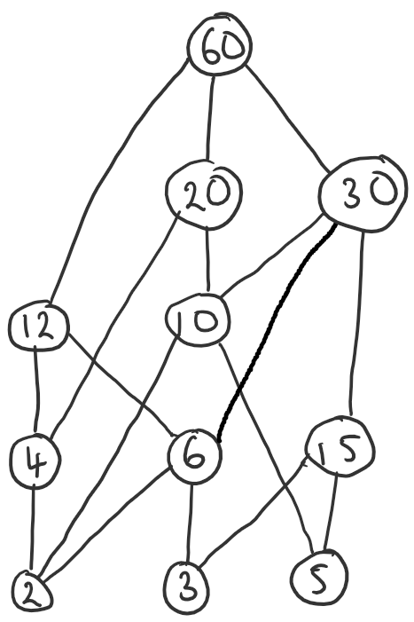

(iii)

Edit: this question is broken because Definition 7.9 assumes that the (set, relation) is a partial order but if k cannot be 1, the relation is not reflexive, which means the definition of partial order doesn’t hold.

Edit 2: Does the < not stand for “strict partial order” which is not reflexive so the question is right?

Minimal: 2, 3, 5

Least: No

Maximal: 60

Greatest: No (see https://piazza.com/class/j8byq7mbpkv3y?cid=19 - k cannot be 1)

[To add: reasons why]

**(d)**

Assuming ~ means bijection, which is defined as there exists a function f : A -> B such that f is a bijection

Answer on pg 78 of the notes (for exercise 48).

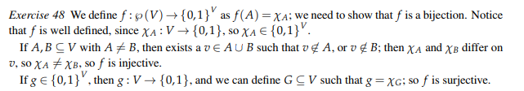

Simpler (maybe wrong) answer:

For any set V, with n elements, the set p(V) yields 2n elements.

(0,1)^V denotes the set of all functions from V => (0,1), which is also 2n elements.

(idk something about same number of elements, so bijection is possible?)

(Broski this doesn't work for infinite sets)